**The Enrollment form**

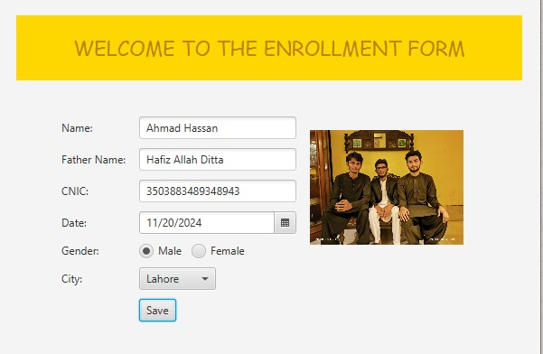

This JavaFX application provides an enrollment form for students, where users can input personal details such as name, father's name, CNIC, date, gender, and city. The form includes options for uploading an image and allows the user to save the entered information. Upon submission, the details of the student are displayed in the console with each attribute shown on a new line. The application uses a simple graphical interface with basic form fields and event handling to capture and store the data.

**The Console output**

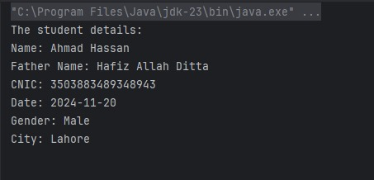

When the user clicks the "Save" button, the application stores the student details entered in the form and displays them in the console. The output will be displayed under the heading "The student details" with each field on a separate line. This includes the student's name, father's name, CNIC, date, gender, city, and the image file path (if an image was selected). The details are shown clearly, allowing for easy verification of the inputted data.